Rebecca Farlow
Kaitohu Hoahoa Mātāmua / Principal Advisor, Brand and Design

National Headquarters
Level 12, 80 The Terrace
PO Box 2133, Wellington, 6140

Ph: +64 21 745432

Rebecca.Farlow@fireandemergency.nz
www.fireandemergency.nz

- Open a new email in outlook.
- Click on signature, and click ‘signatures’ on the drop down menu.

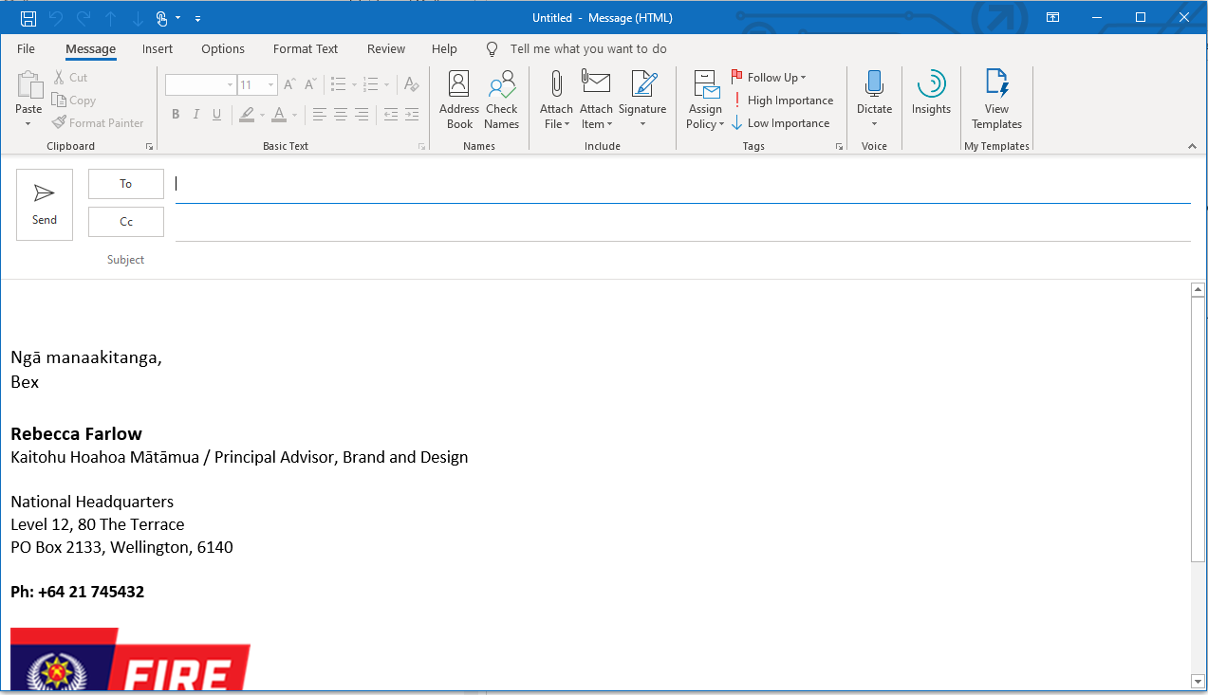

- Copy the above template, update it with your information and paste it in the box at the bottom.

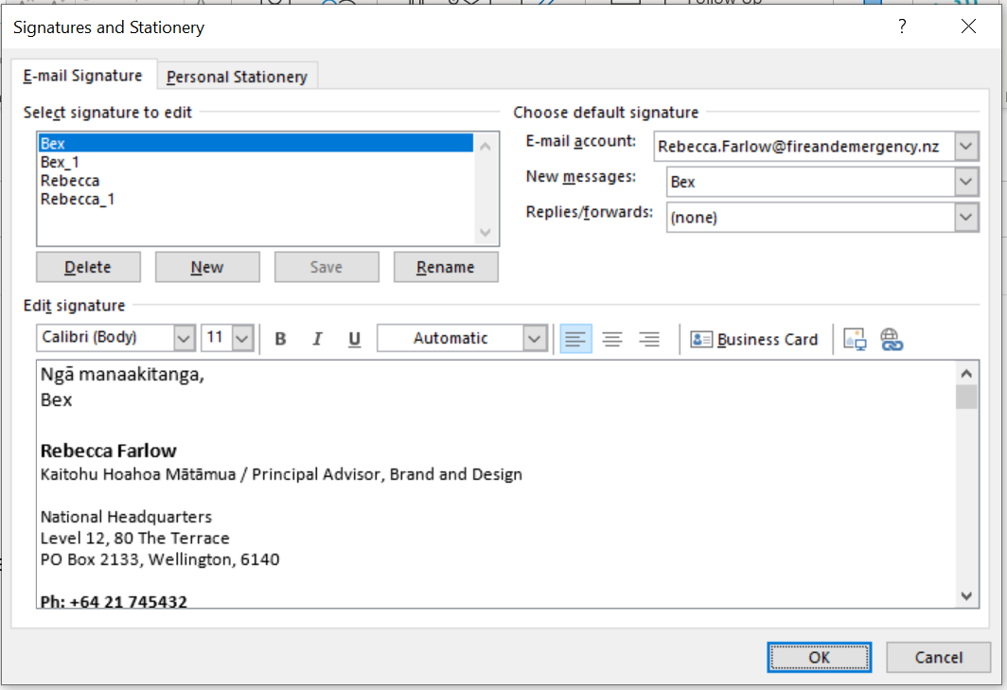

- Make sure to save the signature, you can also rename it if you wish, and make sure it’s always on new messages.

And that should be it – get in touch with communications@fireandemergency.nz if you have any trouble.

